
📚 UNCLE SAM’S BOOKSTORE MANAGEMENT SYSTEM
LOGBOOK REPORT.
STUDENT DETAILS
Student Name | Samuel Muthee Wainaina
Admission Number | BBIT/2024/55411
Course | Bachelor of Business Information Technology
Unit Code | BIT3208
Unit Name | Advanced Web Design and Development
Lecturer Name | Mr.Nyoro
Semester / Academic Year | Year 3, sem 2

PROJECT DETAILS
Project Title | Uncle Sam's Bookstore Management System
Selected Technologies | PHP + MySQL (XAMPP)
Frontend | HTML, CSS, JavaScript
Backend | PHP
Database | MySQL via phpMyAdmin
Design Tool | Figma

ONLINE PORTFOLIO / GITHUB LINK
Github | https://github.com/tastysam/BIT3208-UncleSam-Bookstore/tree/7f91e0409cc60d1c6f358c870b005803e77eecf7/BBIT202455411_BIT3208_Advanced%20Web%20Design%20and%20Development
Table of Content
Section | Page
Cover Page | 1
Table of Contents | 2
Week 1: Local Environment Setup | 6
Installation and Testing of Local Development Environment | 6
Figure 1: Installation of XAMPP | 6
Figure 2: Apache and MySQL Running | 7
Figure 3: Localhost Test Page | 7
Figure 4: Hello World Test | 8
Figure 5: Database Connection Test | 9
Student Reflection | 9
Week 2: Wireframes and GUI Design | 9
User Interface Planning and System Design | 9
Figure 1: Hand-drawn Wireframe (Login/Homepage) | 10
Figure 2: Dashboard Layout Design | 11
Figure 3: Mobile View Mockup | 12
Figure 4: GUI Prototype in Figma | 13
Student Reflection | 13
Week 3: JavaScript and PHP Basics | 14
Frontend Interaction and Backend Foundations | 14
Figure 1: JavaScript Form Validation | 14
Figure 2: Password Strength Checker | 15
Figure 3: PHP Syntax Practice | 16
Figure 4: Database Connection Script | 16
Figure 5: Dynamic User Input Handling | 17
Student Reflection | 17
Week 4: Server-Side Components and Backend Development | 18
Development of Login Authentication System | 18
Figure 1: Login Form Screenshot | 19
Figure 2: Form Validation Screenshot | 20
Figure 3: PHP Processing Screenshot | 21
Figure 4: Folder Structure Screenshot | 22
Figure 5: Database Connection and Users Table Screenshot | 22
Student Reflection | 22
Week 5: Database Components and CRUD Operations | 23
CRUD Operations and Database Integration | 23
Figure 1: Database Screenshot (Books Table Created) | 23
Figure 2: Table Creation Screenshot | 23
Figure 3: CRUD Operations (Add & View Books) | 24
Figure 4: Login Database Integration | 25
Figure 5: SQL Query Screenshots (Edit & Delete) | 25
Student Reflection | 25
Week 6: Database Integration and CRUD Operations (Advanced Features) | 26
Figure 1: Week 6 Folder Structure | 26
Figure 2: Additional Sample Data Added | 27
Figure 3: Search Functionality | 27
Figure 4: Server-Side Validation | 28
Figure 5: Prepared Statements Implementation | 29
Student Reflection | 29
Week 7: User Authentication and Session Management | 30
Figure 1: Week 7 Folder Structure | 30
Figure 2: User Registration with Password Hashing | 30
Figure 3: Login System and Session Creation | 32
Figure 4: Login Attempt Limiting | 33
Figure 5: Protected Dashboard and Logout | 35
Week 8: Responsive Web Design and Mobile-First Development | 36
Figure 1: Week 8 Folder Structure | 36
Figure 2: Responsive Desktop Book Showcase | 37
Figure 3: Mobile Book Showcase | 37
Figure 4: Responsive Tablet View | 39
Figure 5: Viewport Meta Tag and Responsive Dashboard | 40

WEEK 1: Local Environment Setup
Title
Installation and Testing of Local Development Environment
Required Evidence
Fig 1: Installation of XAMPP
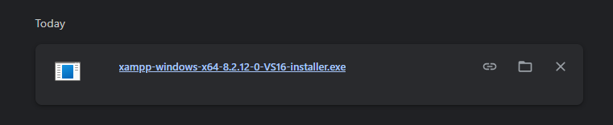
Fig 1: XAMPP installation showing successful setup of the local development environment on the computer.
Fig 2: Apache and MySQL Running
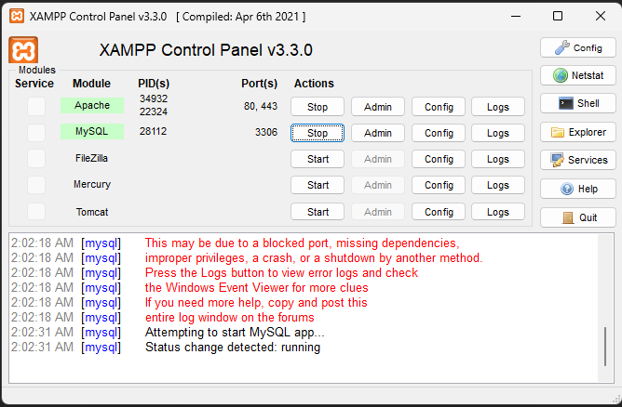
Fig 2: XAMPP Control Panel showing Apache and MySQL services running successfully, confirming the local development environment is operational.
Fig 3: Localhost Test Page
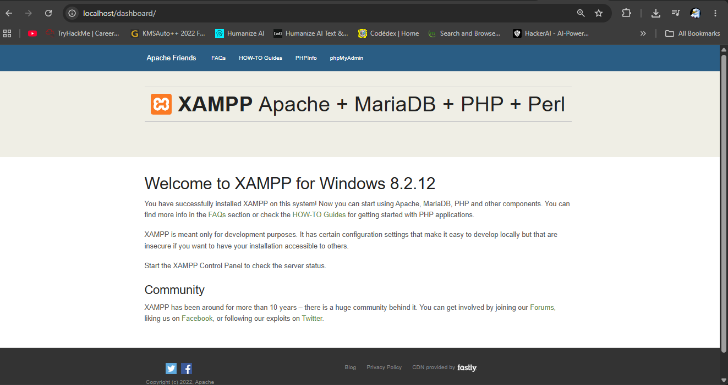
Fig 3: Browser successfully loading the localhost page confirming that the Apache web server is correctly configured and operational on the local machine.
Fig 4: Hello World Test
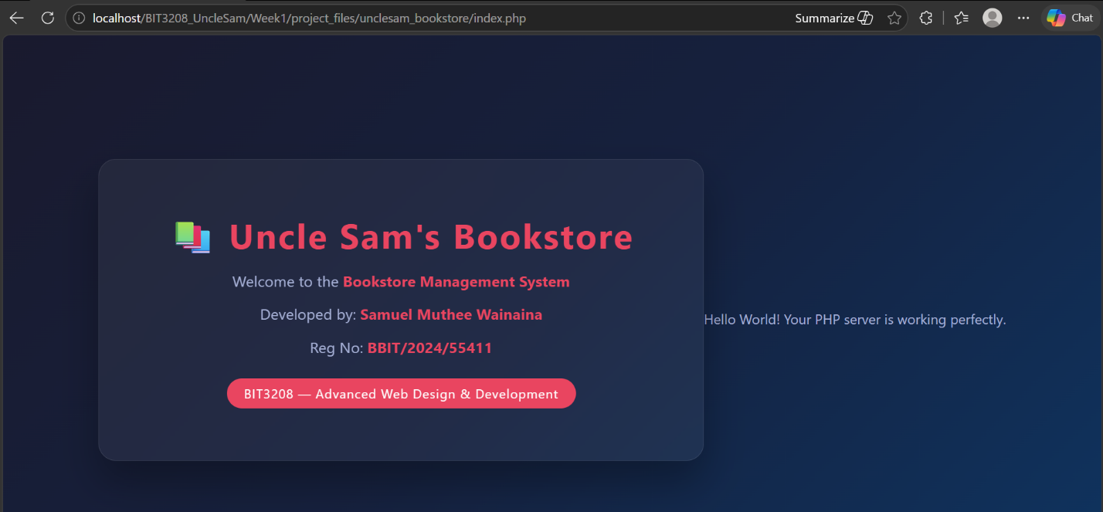
Fig 4: Hello World PHP test page (index.php) confirming that PHP is correctly installed and processing server-side scripts within the local development environment.
Fig 5: Database Connection Test
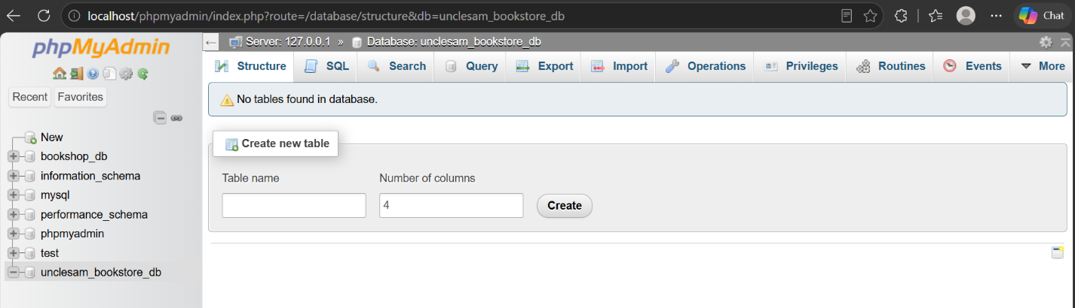
Fig 5: Successful database connection between PHP and MySQL using mysqli_connect() confirming that Apache and MySQL services are properly configured in XAMPP.

Student Reflection
In week one, I successfully set up XAMPP as my local server setup. I had both the Apache service and MySQL service running and checked their status using the XAMPP control panel. I verified that my localhost was running by opening it on my browser. I created a “Hello World” PHP script to check whether PHP is running on my system. Although I have made a “Hello World,” PHP script, I did a few more things. Also, I created a database named “unclesam_bookstore_db” and then checked connectivity using mysqli_connect().

WEEK 2
Wireframes and GUI Design
Title
User Interface Planning and System Design
Required Evidence
Fig 1: Hand-drawn Wireframe (Login / Homepage)
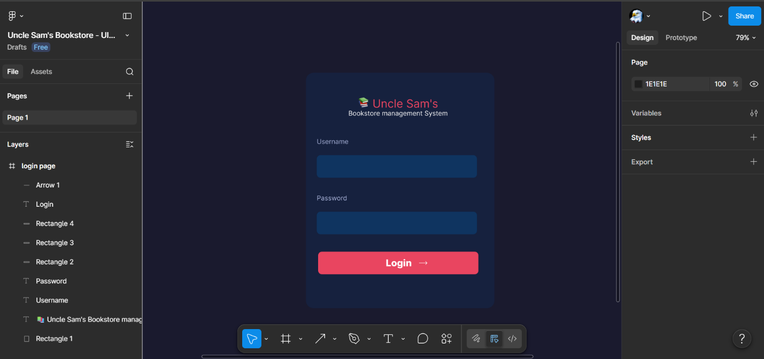
Fig 1: Hand-drawn wireframe of the Login page showing the initial layout plan for Uncle Sam's Bookstore Management System.
Fig 2: Dashboard Layout Design

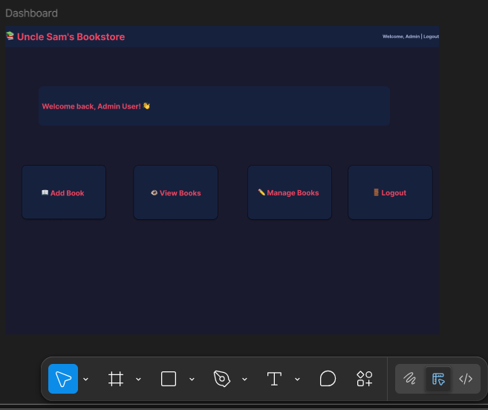
Fig 2: Dashboard wireframe designed in Figma showing the main navigation cards available after successful login to Uncle Sam's Bookstore Management System.
Fig 3: Mobile View Mockup
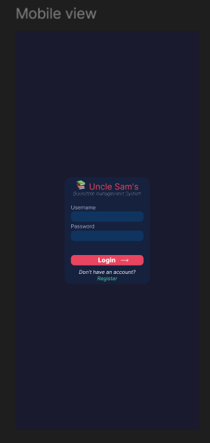
Fig 3: Mobile login interface designed in Figma demonstrating responsiveness and accessibility of Uncle Sam's Bookstore on smaller screen devices.
Fig 4: GUI Prototype in Figma
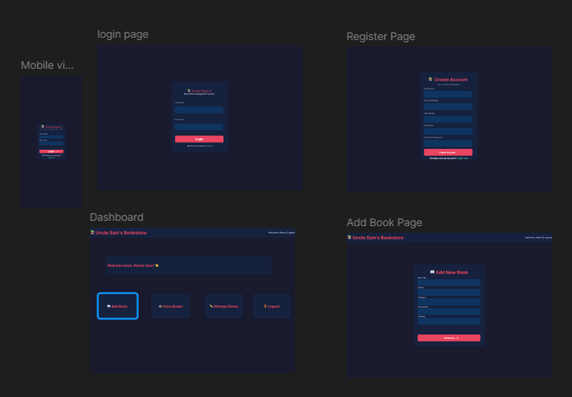
Fig 4: Complete GUI prototype designed in Figma showing the Login, Register, Dashboard, and Add Book pages for Uncle Sam's Bookstore Management System.
Student Reflection
During Week 2, the User Interface Design phase, the Figma software was employed to create the UI for Uncle Sam’s Bookstore Management System. Wireframes were made for the Login page, Register page, Dashboard, Add Book page, and the Mobile Login screen. A proper navigation scheme was developed to make sure that there was an easy transition from one page to another starting from login to logout pages through adding books. Dark navy and red colors were chosen as the primary colors to enhance readability.
WEEK 3
JavaScript and PHP Basics
Title
Frontend Interaction and Backend Foundations
Required Evidence
Fig 1: JavaScript Form Validation
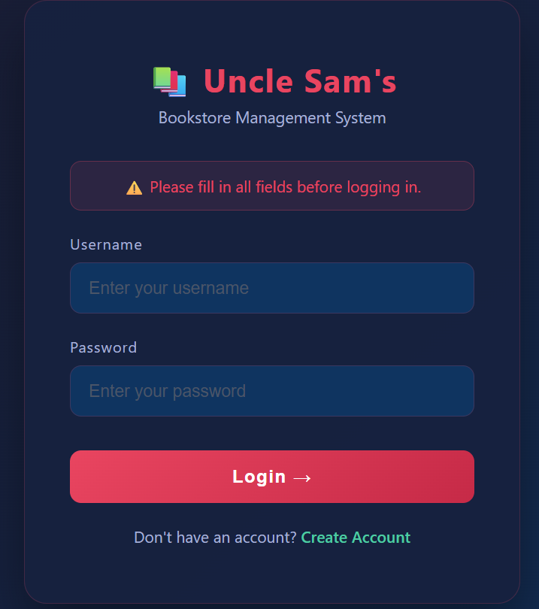
Fig 1: JavaScript form validation on the login page preventing users from submitting empty username or password fields in Uncle Sam's Bookstore.
Fig 2: Password Strength Checker
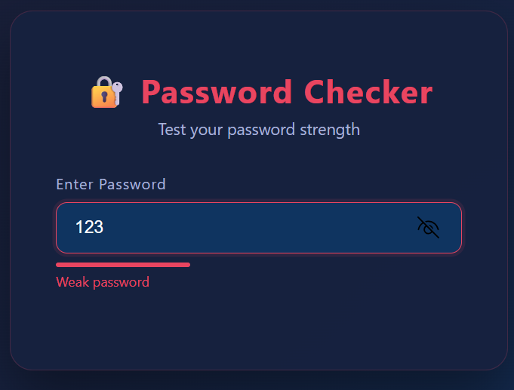
Fig 2: Password strength checker providing real-time feedback showing Weak, Medium, or Strong ratings to improve password quality during registration.
Fig 3: PHP Syntax Practice
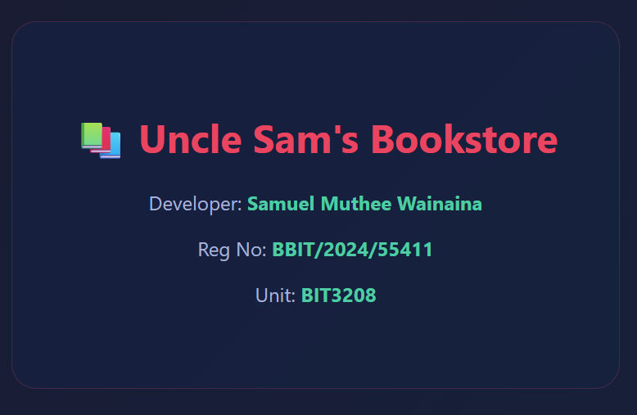
Fig 3: Basic PHP script (welcome.php) demonstrating variable declaration and dynamic content output using the echo statement for Uncle Sam's Bookstore.
Fig 4: Database Connection Script
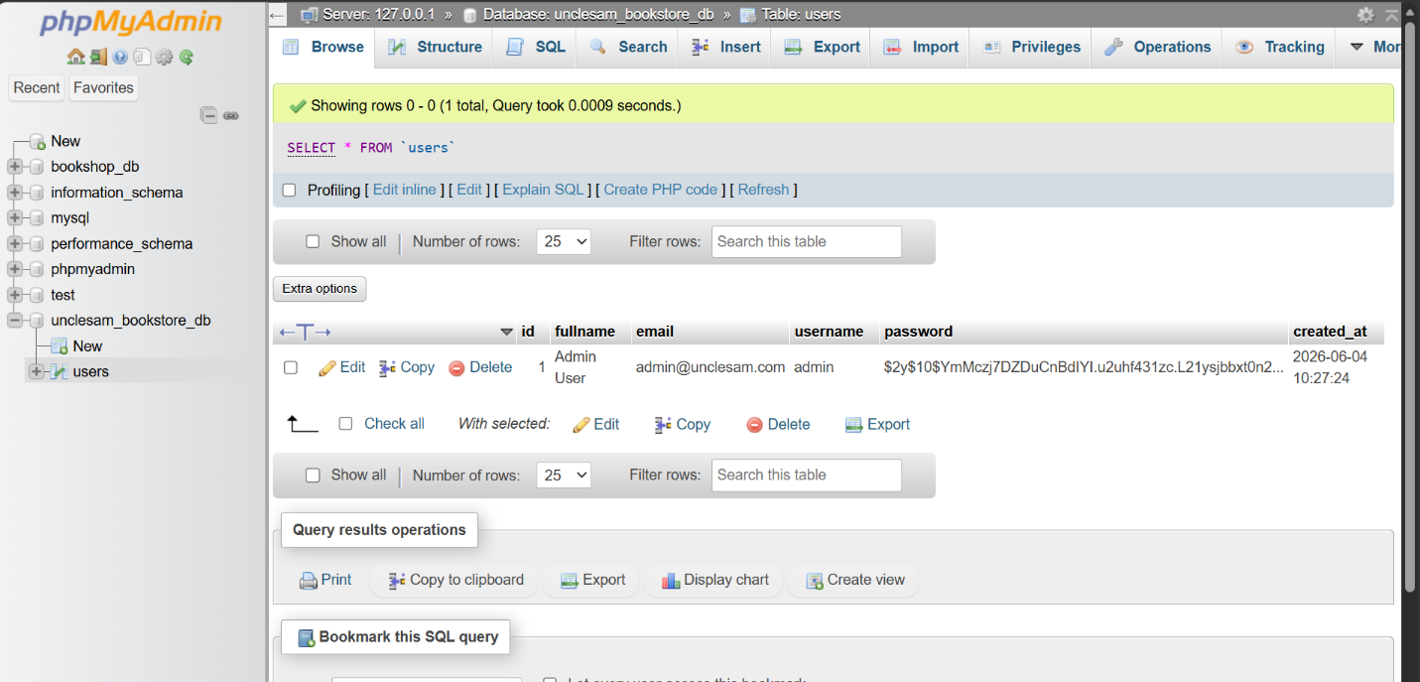
Fig 4: PHP database connection script (db_connect.php) using mysqli_connect() showing successful connection to the unclesam_bookstore_db MySQL database.
Fig 5: Dynamic User Input Handling

Fig 5: Dynamic user input handling using PHP GET method in user_input.php and display.php to process and display information submitted through an HTML form.
Student Reflection
In week 3, I designed the frontend and backend structure of Uncle Sam's Bookstore website. JavaScript was used on the login page to validate the fields. Password checking during the process of registration was also done for users. PHP and variables along with the 'echo' function were used in welcome.php. The database connection file was checked for errors. Dynamic input using GET method was done for understanding the exchange between frontend HTML forms and backend PHP files.

WEEK 4
Server-Side Components and Backend Development
Title
Development of Login Authentication System
Required Evidence
Fig 1: Login Form Screenshot
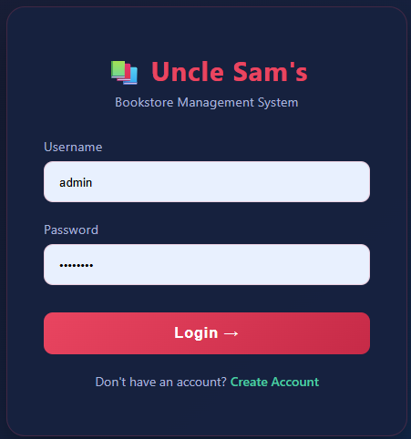
Fig 1: Login form (login.php) built with HTML and CSS allowing users to enter their username and password to access Uncle Sam's Bookstore Management System.
Fig 2: Form Validation Screenshot
Fig 2: JavaScript and PHP form validation working together to prevent invalid login attempts and display appropriate error messages on the login page.
Fig 3: PHP Processing Screenshot (Registration and Login)
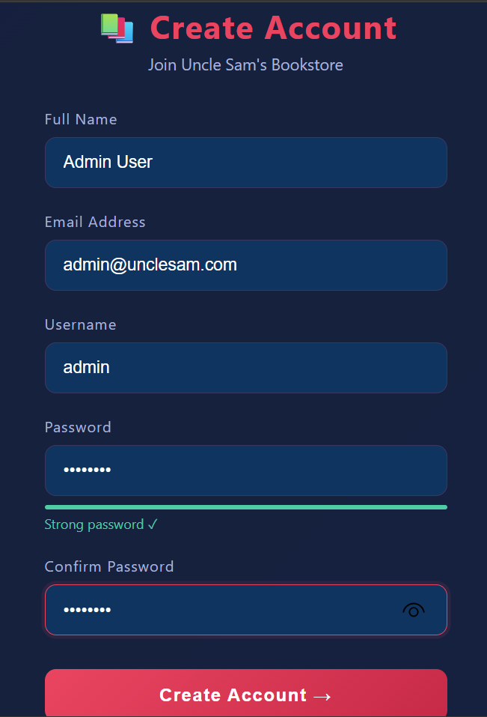
Fig 3: PHP processing scripts (register_process.php and process_login.php) handling form submissions, verifying credentials against the database, and managing PHP sessions.
Fig 4: Folder Structure Screenshot
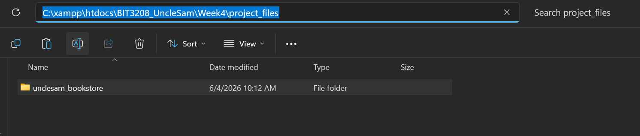
Fig 4: Professional project folder structure for Uncle Sam's Bookstore showing all PHP files, stylesheet, and JavaScript file organized inside the unclesam_bookstore directory.
Fig 5: Database Connection and Users Table Screenshot

Fig 5: Users table created in the unclesam_bookstore_db MySQL database storing registration records with fields for fullname, email, username, and hashed password.
Student Reflection.
In Week 4, I created an authentication system for Uncle Sam’s Bookstore. Users table was made in MySQL where user details can be saved. The register form was linked to register_process.php that adds the new users with their password stored in hash format using the password_hash function. Login form was linked to process_login.php that checks whether the given user details match or not using password_verify function. Sessions in PHP were used to keep the dashboard secure by blocking any unauthorized access.

WEEK 5
Database Components and CRUD Operations
Title
CRUD Operations and Database Integration
Required Evidence
Fig 1: Database Screenshot (Books Table Created) 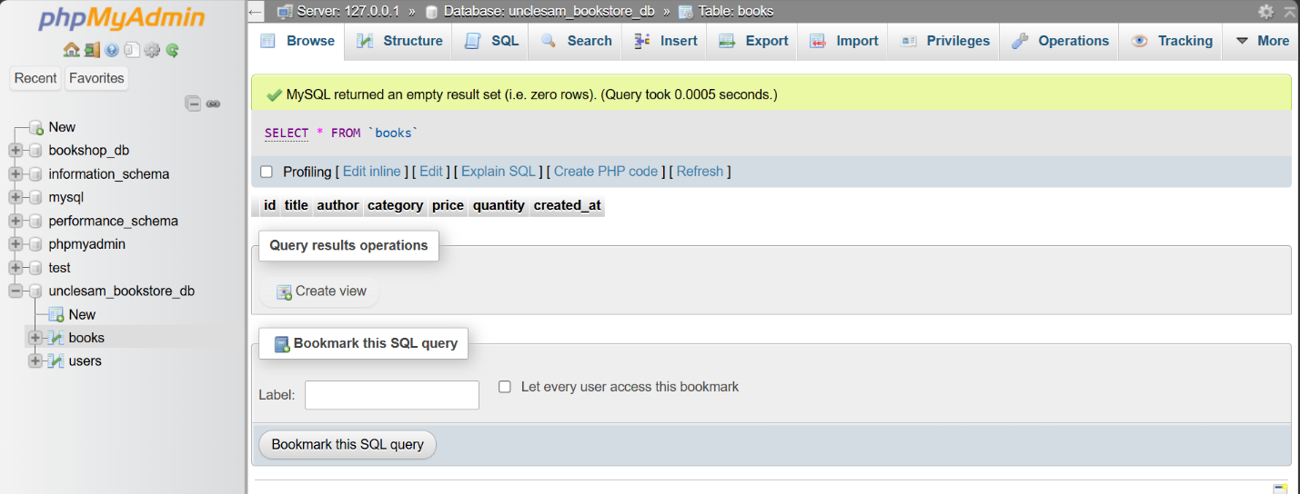
Fig 1: Books table created in the unclesam_bookstore_db MySQL database with fields for id, title, author, category, price, quantity, and created_at timestamp.
Fig 2: Table Creation Screenshot
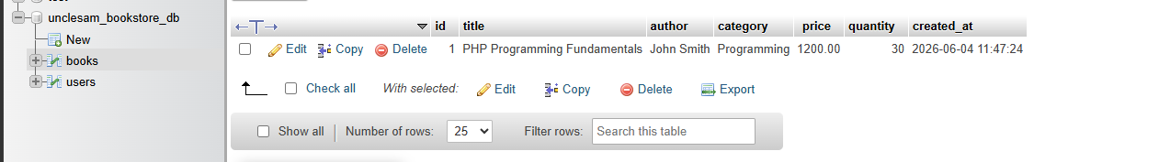
Fig 2: SQL CREATE TABLE statement executed in phpMyAdmin successfully creating the books table to store Uncle Sam's Bookstore inventory records.
Fig 3: CRUD Operations Screenshot (Add and View Books)

Fig 3: Add Book form (add_book.php) used to insert a new book record into the database and View Books page (view_books.php) displaying all inventory records dynamically from MySQL.
Fig 4: Login Database Integration Screenshot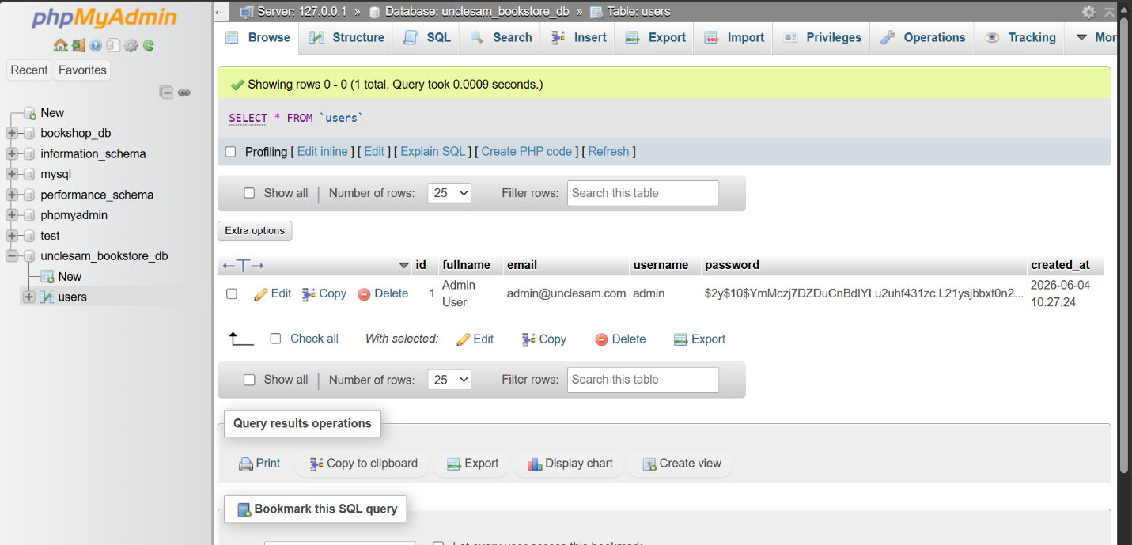

Fig 4: Registered user record visible in the users table in phpMyAdmin confirming that the registration form successfully inserts data into the MySQL database.
Fig 5: SQL Query Screenshots (Edit and Delete)
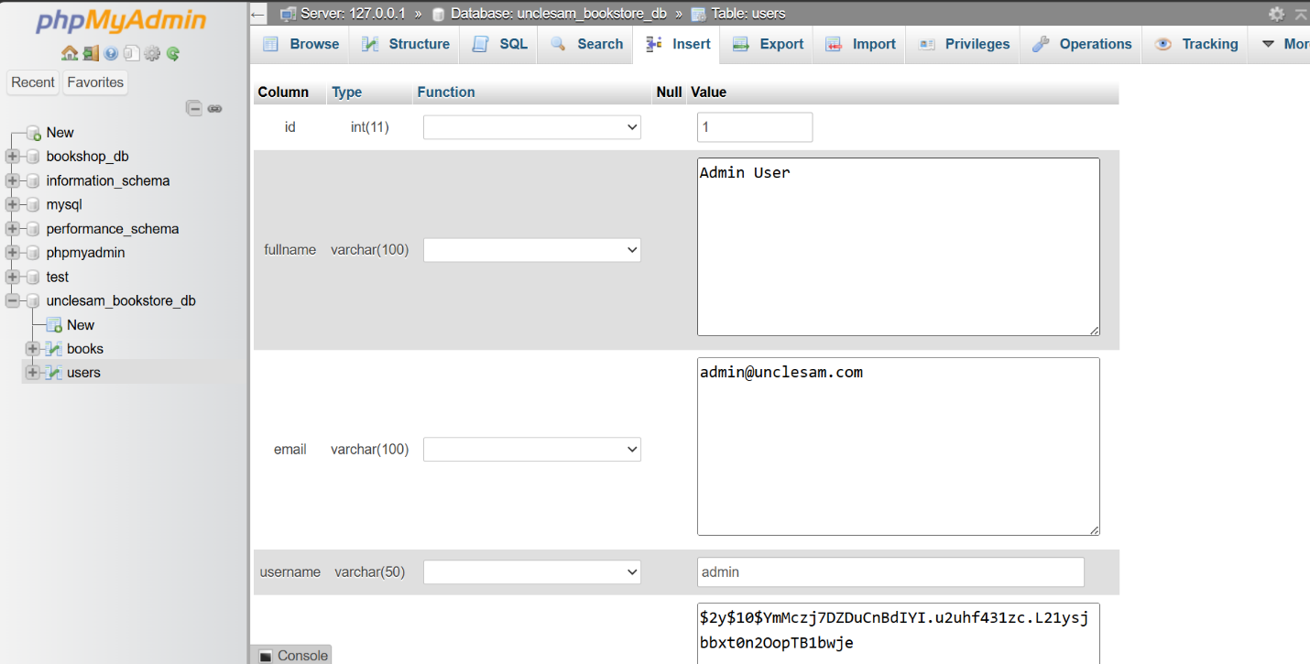
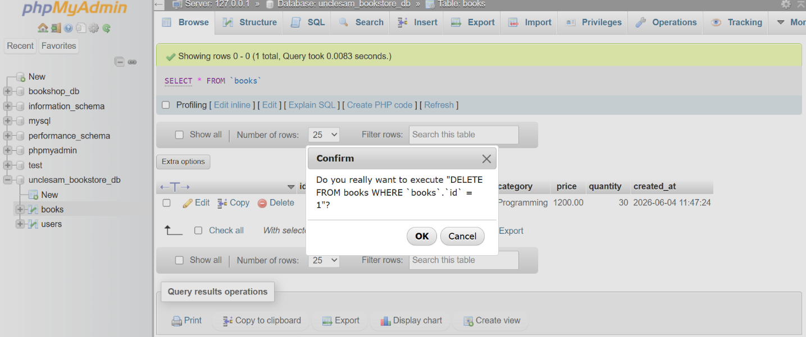
Fig 5: Edit Book page (edit_book.php) showing pre-filled form loaded from database and successful deletion of a book record using the DELETE FROM books WHERE id query.
Student Reflection.

In Week 5, I have completed adding full CRUD functionality to the Uncle Sam’s Bookstore Management System. In order to keep the book information, the books table was added to the database using MySQL. To add new entries to the database, INSERT INTO is used with the Add Book form. To get all entries from the database, SELECT is used by the View Books. For Update operation, UPDATE is used after loading the existing data by the Edit Book form. For Delete operation, DELETE FROM statement is used with a confirmation box. All functionalities were tested and worked well.

WEEK 6
Database Integration and CRUD Operations

Title
Database Integration and CRUD Operations (Advanced Features)

Required Evidence

Fig 1: Week 6 Folder Structure
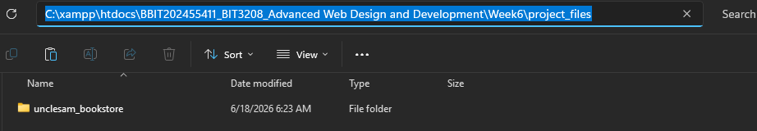
Fig 1: Week 6 folder structure prepared for database integration and CRUD operations development activities.
Fig 2: Additional Sample Data Added
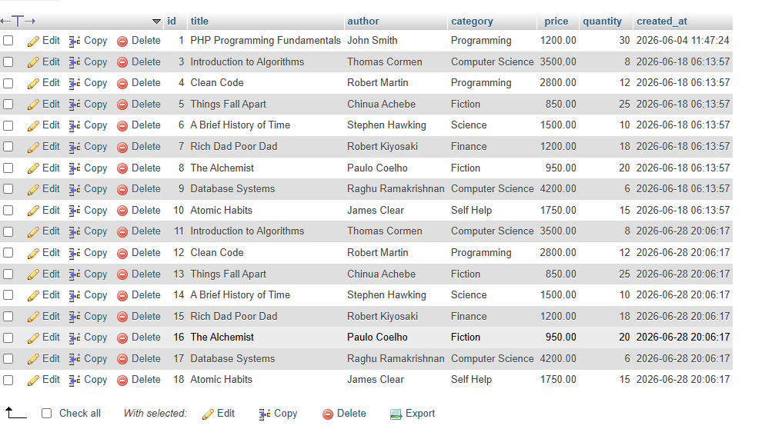
Fig 2: Sample book records successfully inserted into the books table using SQL INSERT statements, demonstrating database population and data management within the unclesam_bookstore_db database.

Fig 3: Search Functionality
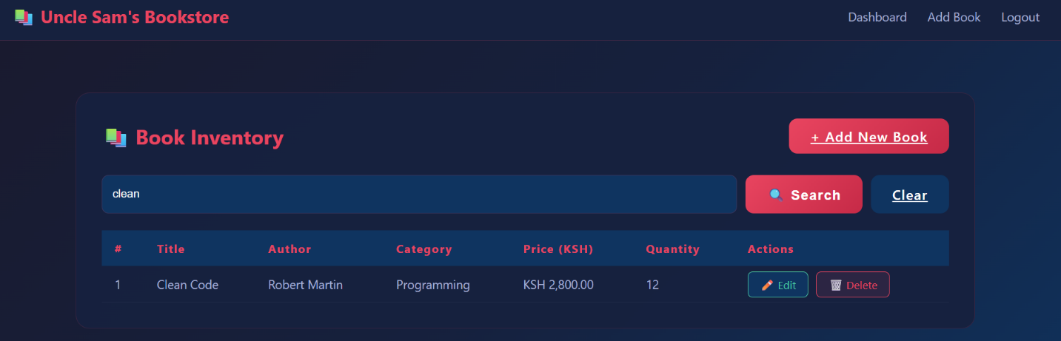
Fig 3: Search functionality implemented on the View Books page allowing users to filter book inventory by title, author, or category using PHP prepared statements for secure and efficient database querying.
Fig 4: Server-Side Validation

Fig 4: Server-side PHP validation implemented in insert_book.php rejecting invalid inputs such as zero price, demonstrating input validation best practices as outlined in the course material on CRUD security.
Fig 5: Prepared Statements Implementation
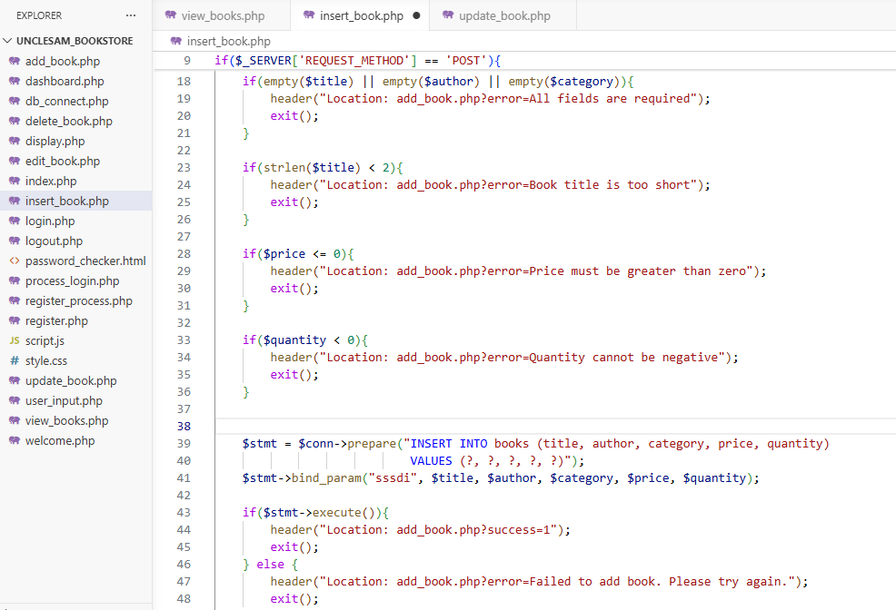
Fig 5: Prepared statement implementation in insert_book.php and update_book.php using bind_param() to prevent SQL injection attacks, following secure coding best practices for database interactions as required by the course.

Student Reflection
During Week 6, I enhanced the database integration of Uncle Sam's Bookstore by adding more sample data to better demonstrate CRUD functionality. A search feature was implemented on the View Books page allowing users to filter books by title or author using a prepared SQL statement. Server-side validation was added to the Add Book form to reject invalid prices and quantities, even if JavaScript validation is bypassed. The insert_book.php script was converted to use prepared statements with bind_param to prevent SQL injection, following secure coding best practices.

WEEK 7
User Authentication and Session Management
Required Evidence
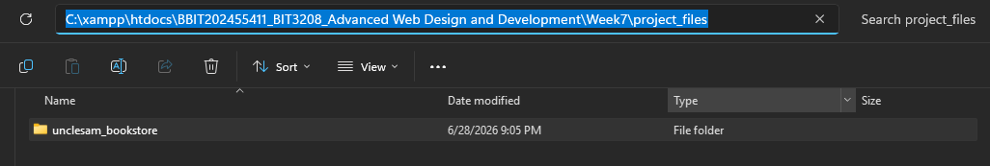
Fig 1: Week 7 folder structure prepared for user authentication and session management development and documentation activities.

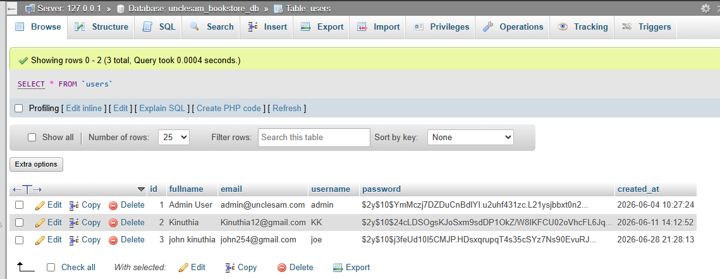
Fig 2: User registration form storing passwords as hashed values using PHP password_hash() function, demonstrating secure credential storage with the hashed password visible in the users table in phpMyAdmin.
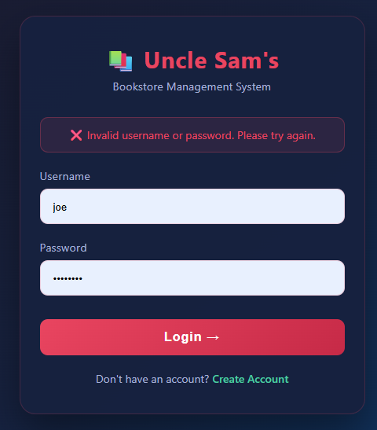
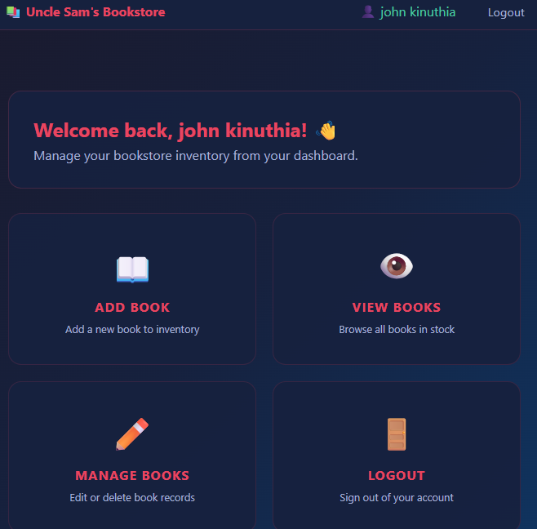
Fig 3: Login system verifying user credentials against the database using password_verify() function and creating a PHP session upon successful authentication, granting access to the protected dashboard.

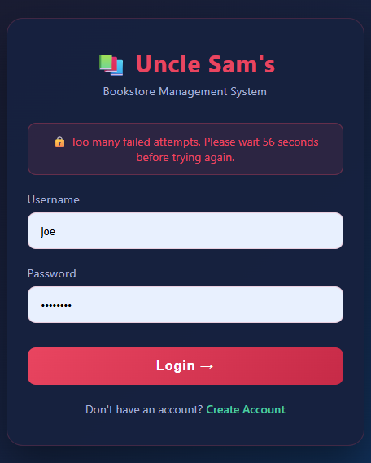
Fig 4: Login attempt limiting preventing brute force attacks by locking out users for 60 seconds after three consecutive failed login attempts, implementing the security best practice outlined in the course material.
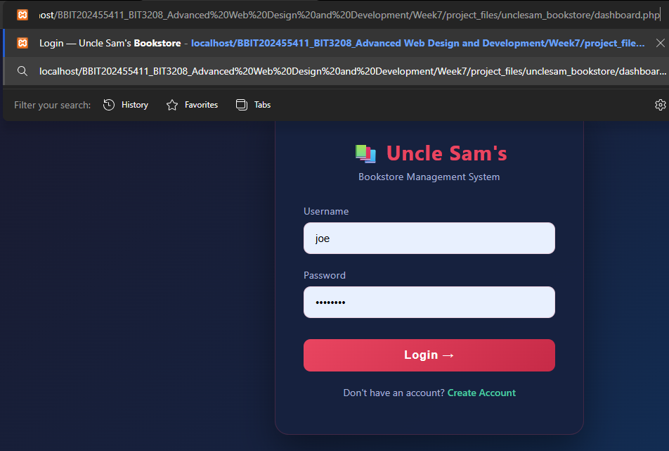
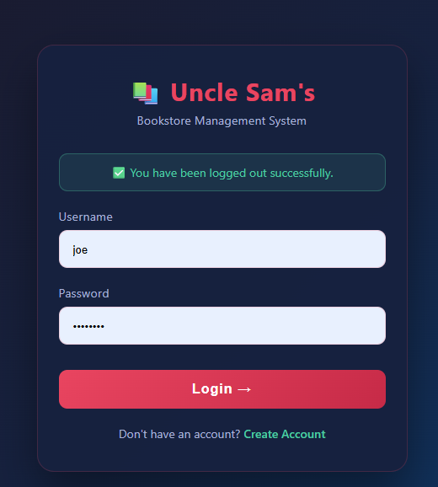
Fig 5: Protected dashboard redirecting unauthorized access attempts to the login page using PHP session validation, alongside logout functionality destroying all session data using session_destroy() to prevent unauthorized access after sign out.

WEEK 8
Responsive Web Design and Mobile-First Development
Required Evidence
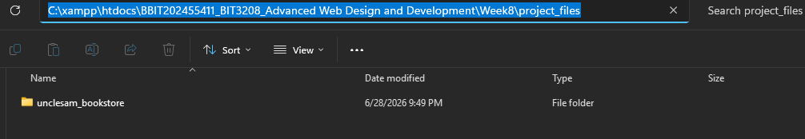
Fig 1: Week 8 folder structure prepared for responsive web design and mobile-first development activities.

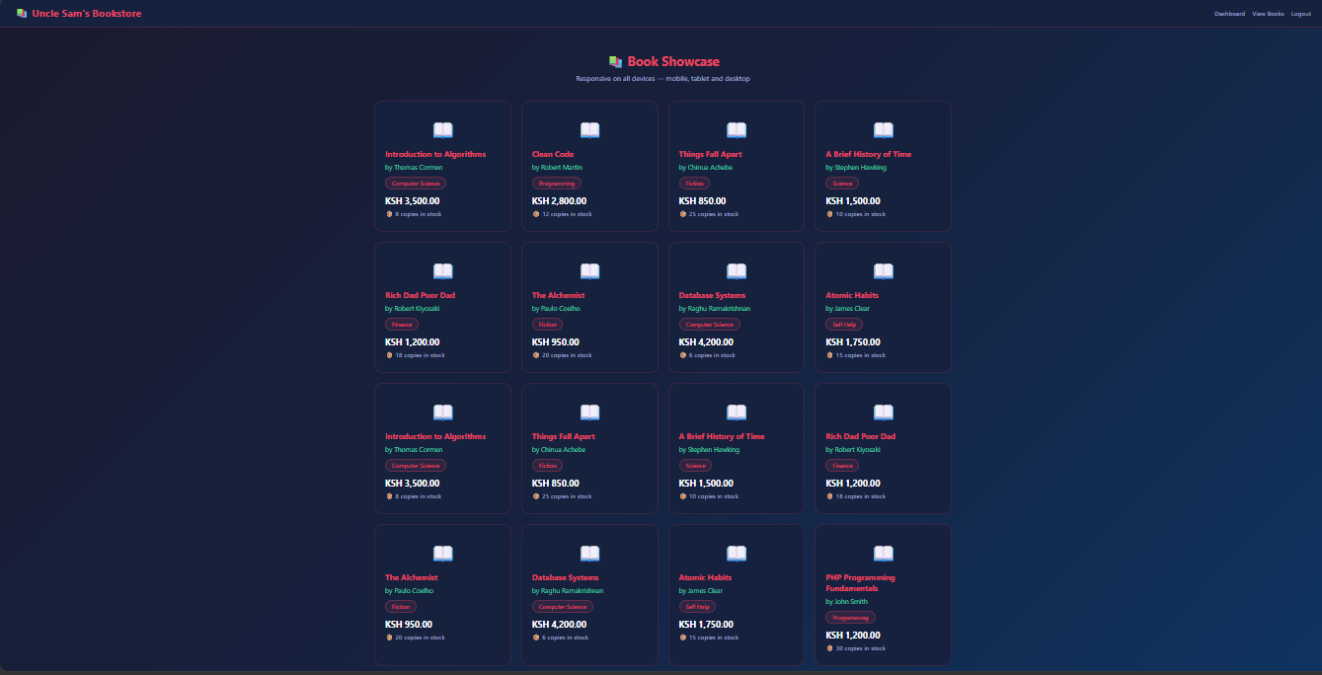
Fig 2: Responsive book showcase page displaying multiple book cards per row on desktop using CSS Grid layout, demonstrating the Mobile-First design approach as required by the Week 8 practical task.
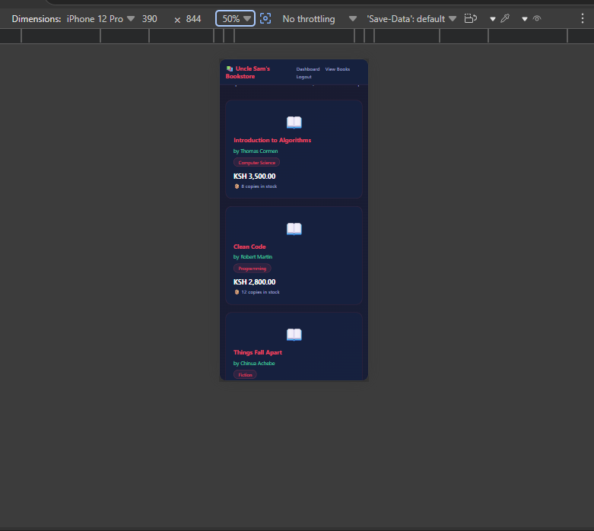
Fig 3: Book showcase page on mobile view displaying single column layout achieved through CSS Grid mobile-first design, with grid-template-columns adjusting from one column on mobile to multiple columns on larger screens.
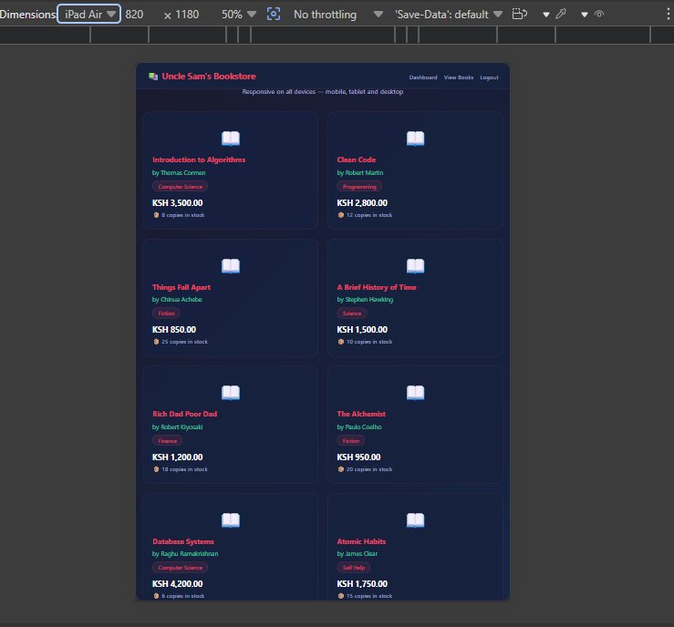
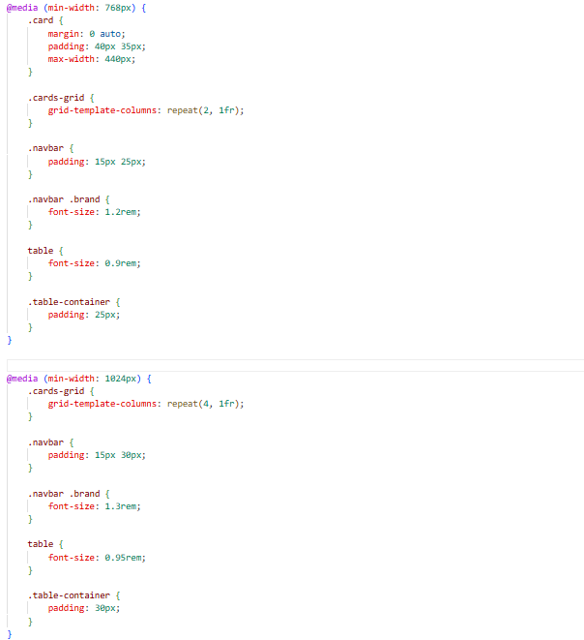
Fig 4: Responsive tablet view displaying two-column grid layout alongside the mobile-first CSS media query code implementing breakpoints at 768px for tablets, 1024px for laptops, and 1440px for desktops.
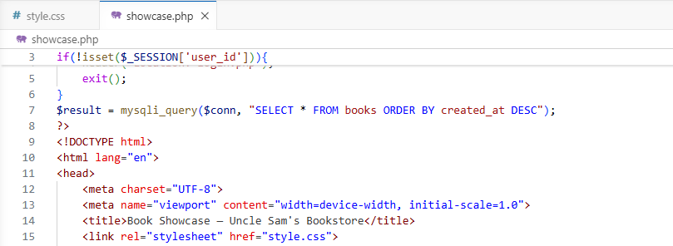
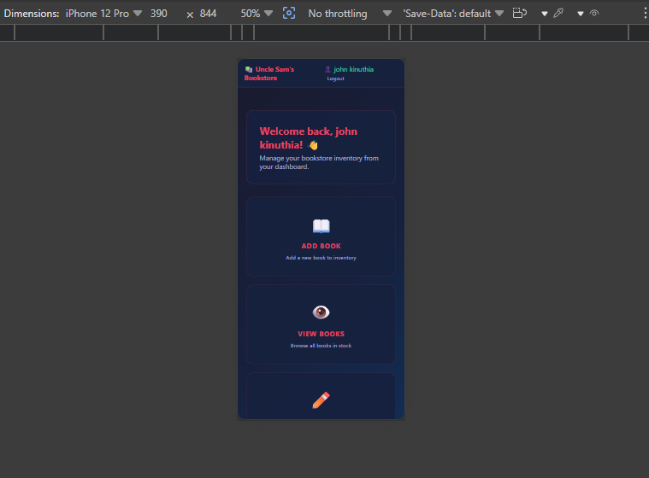
Fig 5: Viewport meta tag implemented across all pages ensuring correct mobile rendering, alongside the responsive dashboard adapting to mobile screen dimensions using CSS Flexbox and Grid confirming the complete system is mobile-friendly.

